Rajesh Kumar
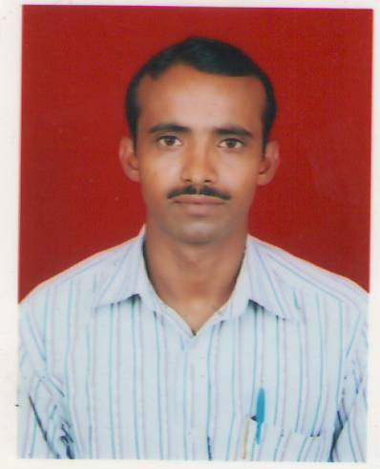

13/6, Anandpuri, West Boring Canal Road, Patna- 800001
E-mail: rajeshkumar983590@gmail.com
Phone- 9709590717; 9835899879

Career Objective

Self motivated individual looking for a challenging career where I can optimize my analytical skills through the domain knowledge that I have to contribute to the growth, development, and transformation of the business that I work for.
Projects Formulated

- Title: Geochemical study of Bed sediments of the River Koshi.
Brief: The objective was to study the pollution level of the River water by collecting the sample of the sediment of river Koshi and also to measure the magnitude of the soil erosion through its sample.
Areas of Interest

- Environment Protection
- Information technology Enabled Services (ITES)
- Elementary Mathematics
Educational Qualification

- Master of Science in Environmental Science from A.N.College, Patna Magadh University during the session 2008-10 having secured 55% of marks.
- Bachelor of Science in Physics (Hons.) A.N.College, Patna Magadh University during the session 2004-07 having secured 62% of marks.
- Intermediate of Science at M. H. S. College Rajapur mainpura, Patna during the period of 2002-04 having secured 52% of marks from Bihar Intermediate Education council Patna.
- Passed Bihar School Examination Board in the year 2002 securing a marks percentage of 63%.
Certifications & Recognitions

- Have been awarded a First Class Grade in Diploma of computer Application from Gandhi Institute of Computer Education & Information Technology in the year 2007.
- Have been awarded a certificate of participation for the clean Environment at Patna book fair 2008.
- Have also been awarded a certificate of senior first aid in the field of health and safety from St. John Ambulance Association.
Personal Traits

- Excellent analytical skills and comprehensive problem solving abilities.
- A very keen observer having a strong desire to work hard and learn.
Personal Profile

Father’s name : Shri Ram Prakash Singh
Mother’s name : Smt. Shakuntala Devi
Date of Birth : 20 October 1984
Hobbies : Reading noble; Internet Surfing
Languages known : English, Hindi

Date:
Place: [RAJESH KUMAR]

